Florida A & M University Board of Trustees
Special Meeting

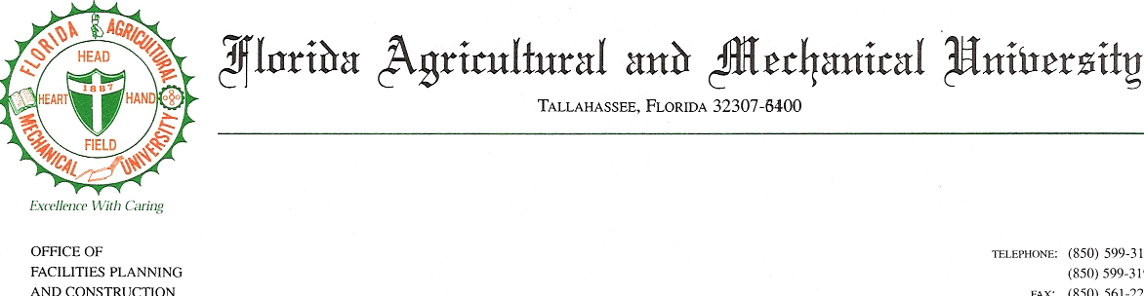
April 21, 2007
10:00 a.m. – 4:00 p.m.

Agenda
REVISED

Bill Jennings, Vice - Chairman

- Opening Remarks Vice -Chair Jennings

- Remarks President Bryant

- Hiring Flow
  - Faculty With and Without Overloads Debra Austin
  - Graduate Assistants
  - Adjuncts

  - Staff (including A&P) Janie Greenleaf
  - Other Personnel Services (including Students)

- Report on Payroll Problems Castell Vaughn Bryant
  - Spring Term 2007
  - Fall Term 2006
  - Prior

- Report on Operational Audits Grace Ali

- KPMG Contracts (Status of Task Orders) Grace Ali
Keith Jackson
Rufus Little
Paul Stepusin, KPMG

- U.S. Department of Labor Report Elizabeth McBride

- Status Report on BOG Task Force

Adjournment

